Date : 27-Mar-26

TEXTSYNTH

VERSION: 1.0.0

OVERVIEW
TextSynth API provides access to large language and multimodal models through a REST API and playground. It allows developers to generate text, images, and speech by sending simple HTTP requests to different AI engines. The API supports models like Mistral, Llama, Stable Diffusion, and Whisper for tasks such as text completion, chat, translation, image generation, speech-to-text, and text-to-speech. Developers can iteratively send prompts, analyze responses, and refine outputs to achieve accurate results. This makes TextSynth useful for building AI applications like chatbots, content generation tools, translation systems, image generators, and voice-based solutions.

Use case:
- Chatbots & Virtual Assistants – Build conversational AI using Mistral or Llama models for customer support and automation.
- Text Generation & Summarization – Generate articles, emails, or summaries from input text.
- Language Translation – Translate text between multiple languages using TextSynth models.
- Image Generation – Create images from text prompts using Stable Diffusion.
- Speech-to-Text & Text-to-Speech – Convert voice to text and generate speech using Whisper and speech models.
- Content Classification & Analysis – Analyze and classify text for sentiment or category-based applications.
- AI-powered Applications – Integrate REST APIs into web or mobile apps for automation and smart features.

Features:
- Multiple Model Access:
Access powerful AI models like Mistral, Llama, Stable Diffusion, and Whisper through a unified REST API for different AI tasks.
- Text Generation & Chat:
Generate high-quality text, perform question answering, summarization, translation, and conversational AI interactions using language models.
- Text-to-Image Generation:
Create images from text prompts using Stable Diffusion for creative, design, and visualization use cases.
- Speech-to-Text & Text-to-Speech:
Convert audio into text and generate speech from text using supported speech models for voice-based applications.
- REST API-Based Integration:
Easily integrate AI capabilities into web and mobile applications using simple HTTP requests and JSON responses.
- Translation & Language Processing:
Support multilingual translation, text classification, and content analysis for global applications.
- Playground & Testing Environment:
Test prompts, models, and outputs in an interactive playground before integrating them into applications.
- Scalable & Developer-Friendly:
Provides lightweight, fast, and flexible APIs that help developers quickly build AI-powered solutions for real-world applications.

GETTING STARTED

Prerequisites
Before you start using the TextSynth Adapter, ensure you have the following:

- HCL Foundry
- TextSynth API Key Account - Get a TextSynth API key
Creating an Account and API Key
  - Navigate toTextSynth account and establish a free account.
  - After creating the account, go to the Settings section to get the TextSynth API key, where the API key can be generated

B. Importing the Data Adapter

You can import the TextSynth Data Adapter into HCL Foundry directly from the Volt MX Forge website or by importing the data adapter zip file.

To import Data Adapter to Volt Foundry, do the following:
- Sign in to the HCL Foundry.
- From the left navigation menu, select API Management.
- In API Management, select Custom Data Adapters.

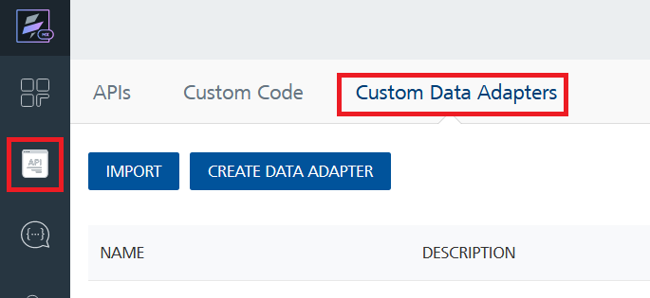

4. Click IMPORT to import a custom data adapter.
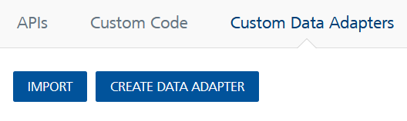
5. On the Import Data Adapter dialog box, click browser to import.

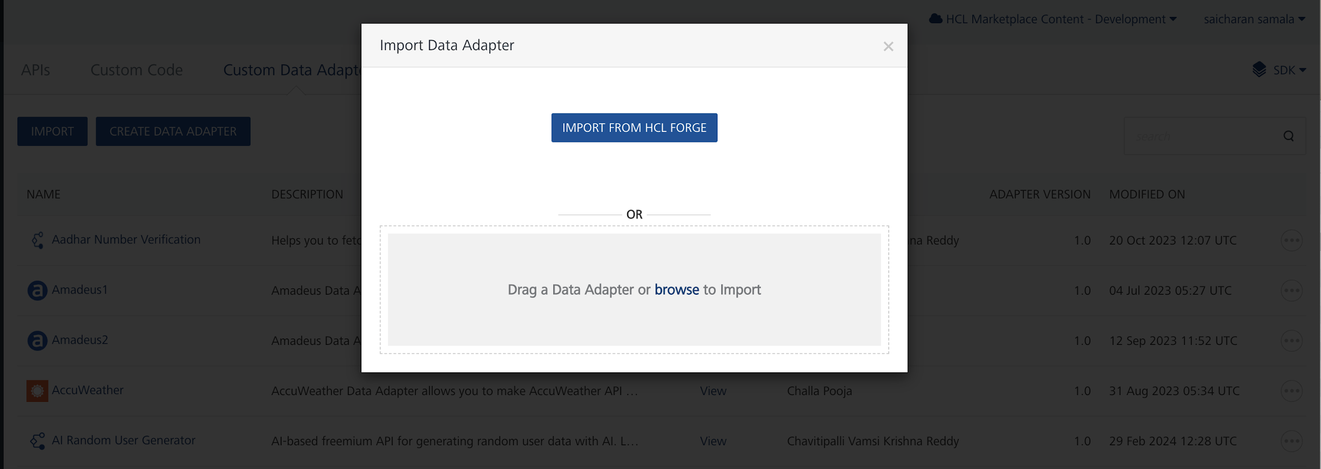
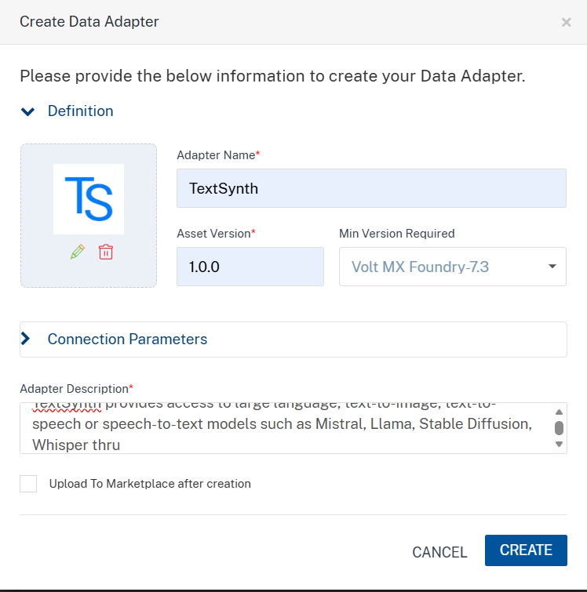

6. Click IMPORT FROM HCL FORGE. The Import Data Adapter from HCL Forge dialog appears with a list of available data adapters.
Click Import. TextSynth Data adapter is listed on the Custom Data Adapters page.
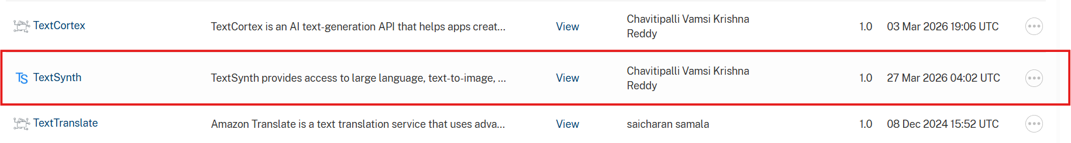
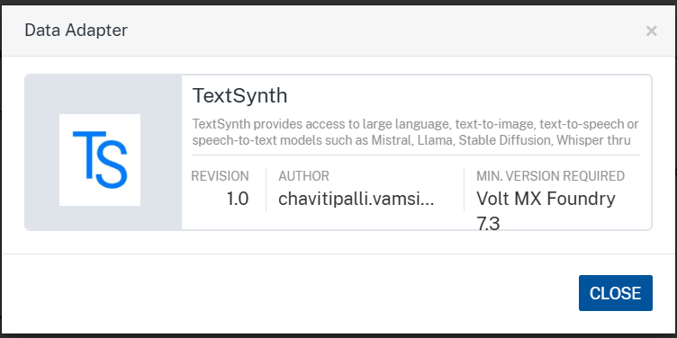
To import the data adapter zip file, do the following:
- Perform steps 1 to 4 in the above procedure
- Drag the data adapter zip file into the Drag a Data Adapter box.
Or
Click browse. The Open dialog appears.
Navigate to the location where you downloaded the data adapter (zip file) on your computer, select the data adapter, and click Open. The Import Data Adapter dialog shows the selected data adapter.
Note: Click Remove if the selected data adapter is not the one that you want to import.

C. Creating an Integration Service with TextSynth:
After you import TextSynth Data Adapter into Foundry, you must create an integration service with service type TextSynth.
To create an integration service with TextSynth, do the following:
- Log on to your HCL Foundry. The Dashboard page appears by default.
- In the left pane, click the API Management menu. The APIs tab opens by default.
- Click the Integration tab. The Integration tab opens with a list of existing integration services.
- Click CONFIGURE NEW. The Service Definition tab opens.
- In the Name box, type a unique name for your service.
- From the Service Type list, TextSynth.
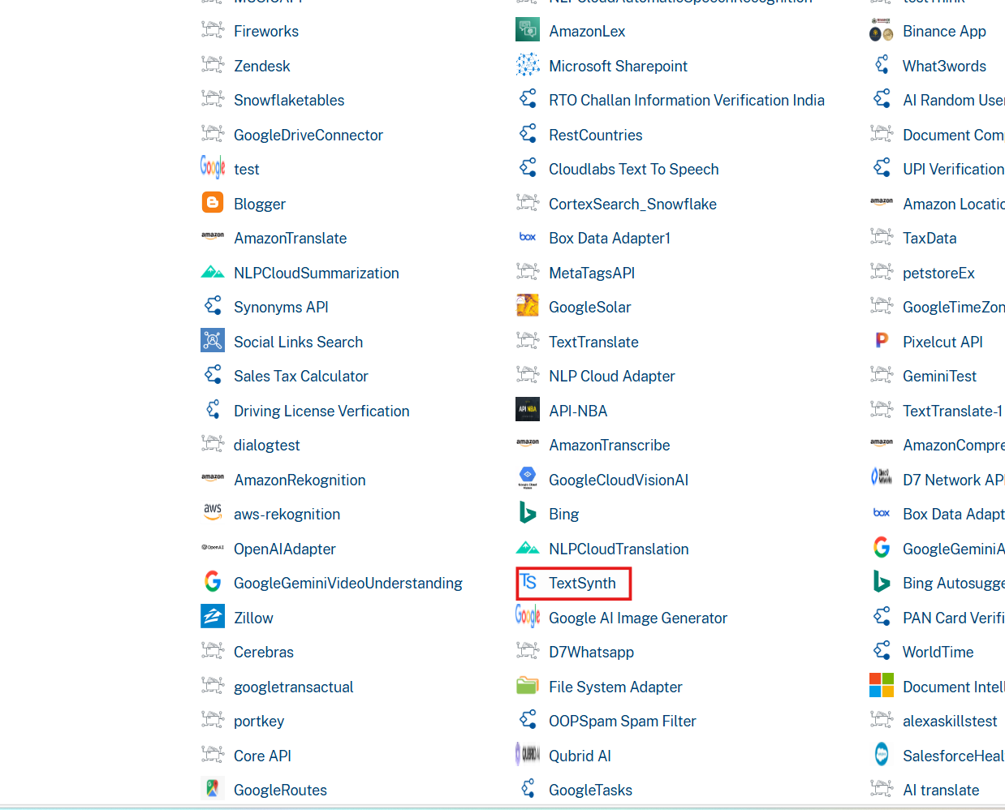
- Click Save

D. Creating an Operation
To make any API call in the HCL Foundry console, you must create an operation for the respective API and then execute the operation. Executing an operation involves making the API call and displaying the response.
This section provides steps to create an operation for the TextSynth.
Steps to create an operation for the TextSynth:
- Log on to your HCL Foundry. The Dashboard page appears by default.
- In the left pane, click the API Management menu. The APIs tab opens by default.
- Click the Integration tab. The Integration page appears with a list of existing integration services.
- From the list of integration services, select the integration service that you have created with the service type TextSynth. The Service Definition tab of the selected integration service opens by default.
- Click the Operations List tab. The Operations List tab opens.
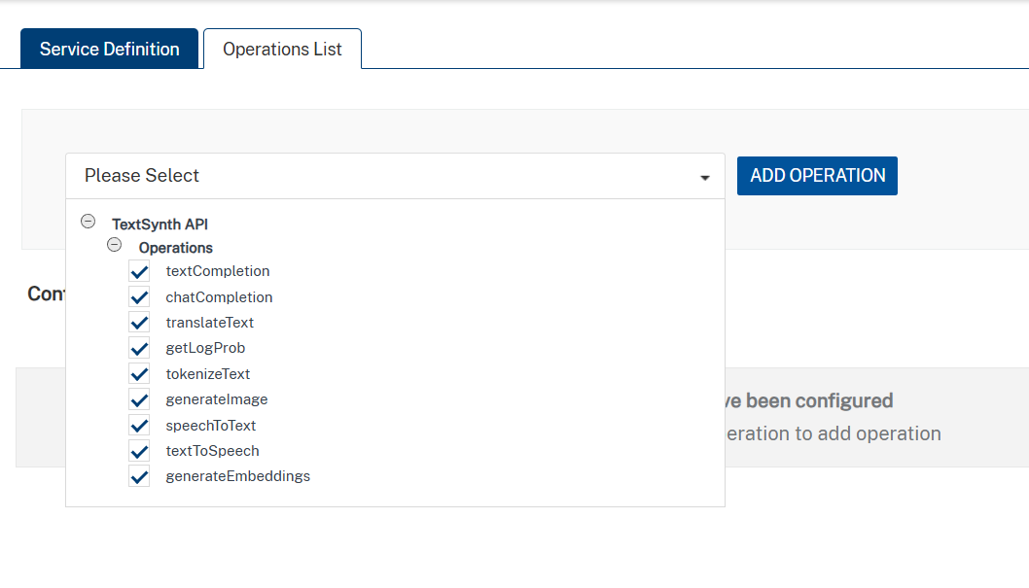
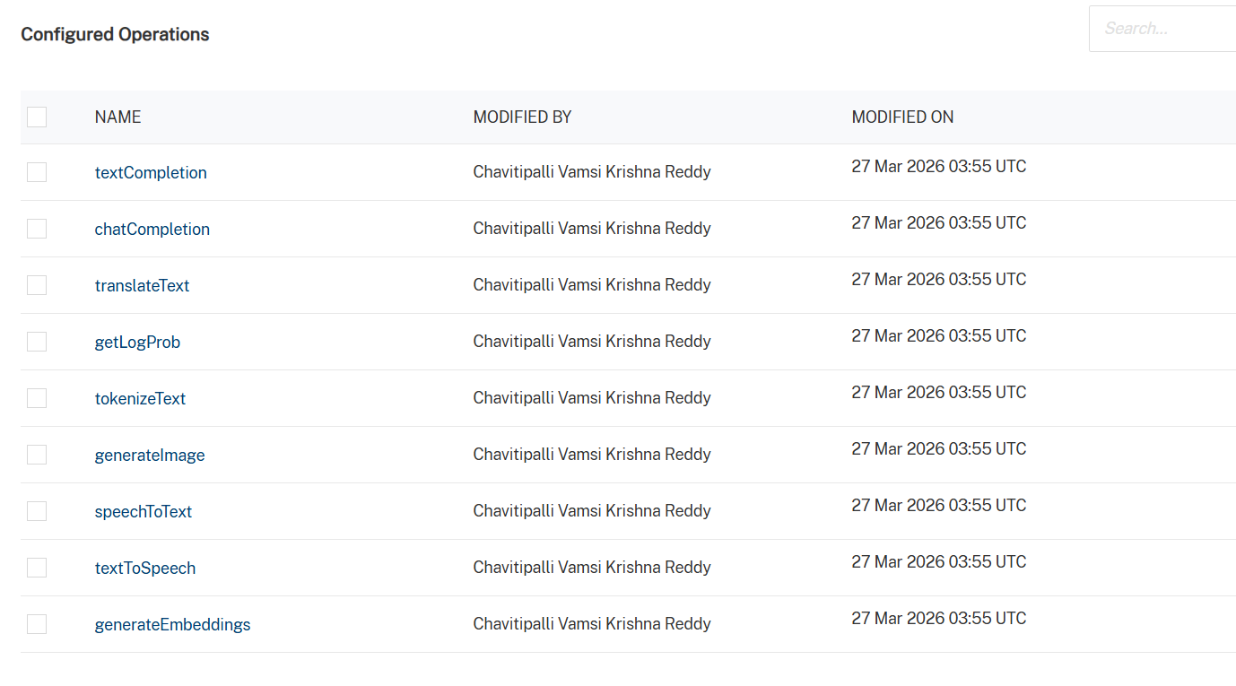
- Select All the operations. Click Add Operations.

E. Executing Operation
Executing an operation involves making the API call by setting the necessary parameters and displaying the response. The procedure to execute any operation is the same, but the request parameters of the APIs vary. This section provides steps to execute the translateText(explained in Creating an Operation).
Steps to execute the translateText operation:
- Log on to your Hcl Foundry. The Dashboard page appears by default.
- In the left pane, click the API Management menu. The APIs tab opens by default.
- Click the Integration tab. The Integration tab opens with a list of existing integration services.
- From the list of integration services, select the integration service that you have created with service type TextSynth. The Service Definition tab of the selected integration service opens by default.
- Click the Operations List tab.
- In the Name box, the name of the operation is displayed by default. If you want, you can change the name.
- On the Request Input tab, in the Body section, for the following parameters, specify the values in the respective boxes under the Test Value column.
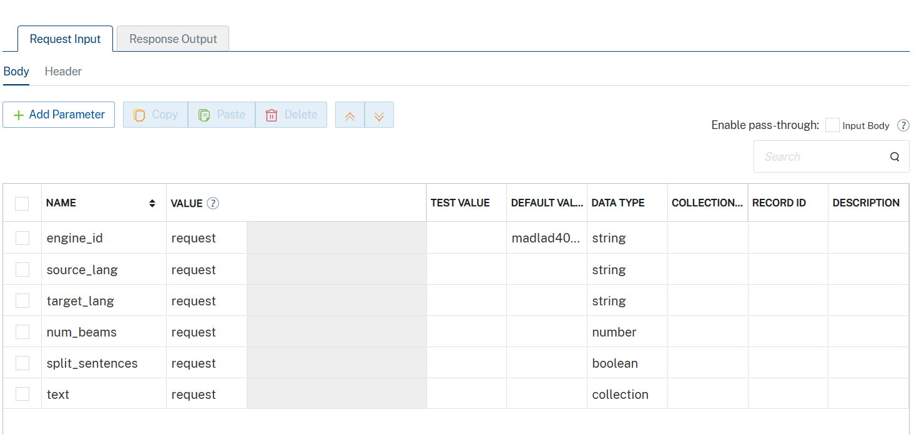
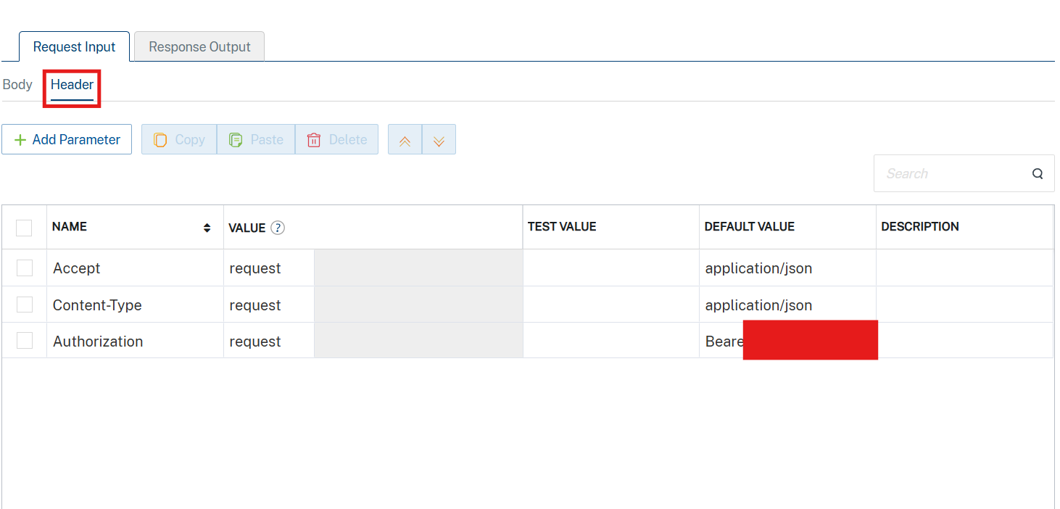
Set the API key value to the default Value generated in the Prerequisites section.
- Click SAVE AND FETCH RESPONSE. The Output Result dialog appears with the response. Otherwise, the Output Result shows an error.
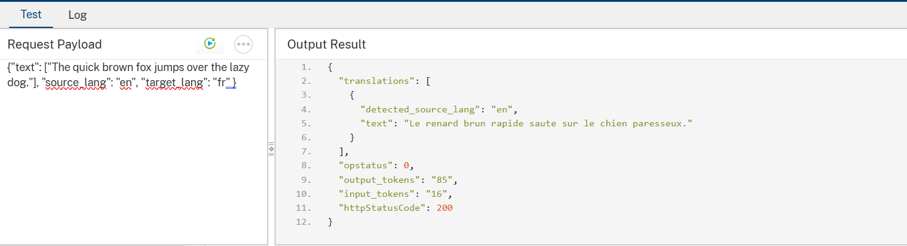

3. Publishing the App in VoltMX FOUNDRY:
After adding the TextSynth Data Adapter to your app and configuring the necessary configurations, you must publish the app to HCL Foundry. For more information, refer to Publish a foundry app.
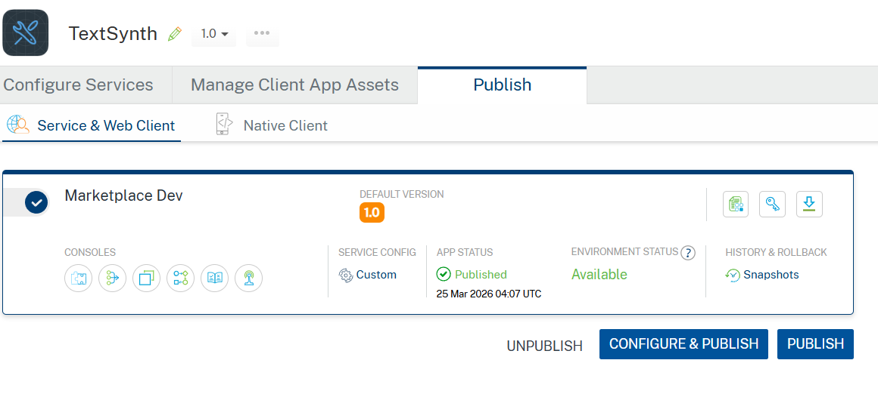

4. REFERENCES

Endpoint documentation
TextSynth account

5. REVISION HISTORY
Adapter version 1.0.0:

Known Issues
None

Limitations
None

